**Project Design Phase-II**

**Data Flow Diagram & User Stories**

|  |  |
| --- | --- |
| Date | 06 October 2022 |
| Team ID | PNT2022TMID26473 |
| Project Name | Project - IOT based safety gadget for child safety monitoring and notification |
| Maximum Marks | 4 Marks |

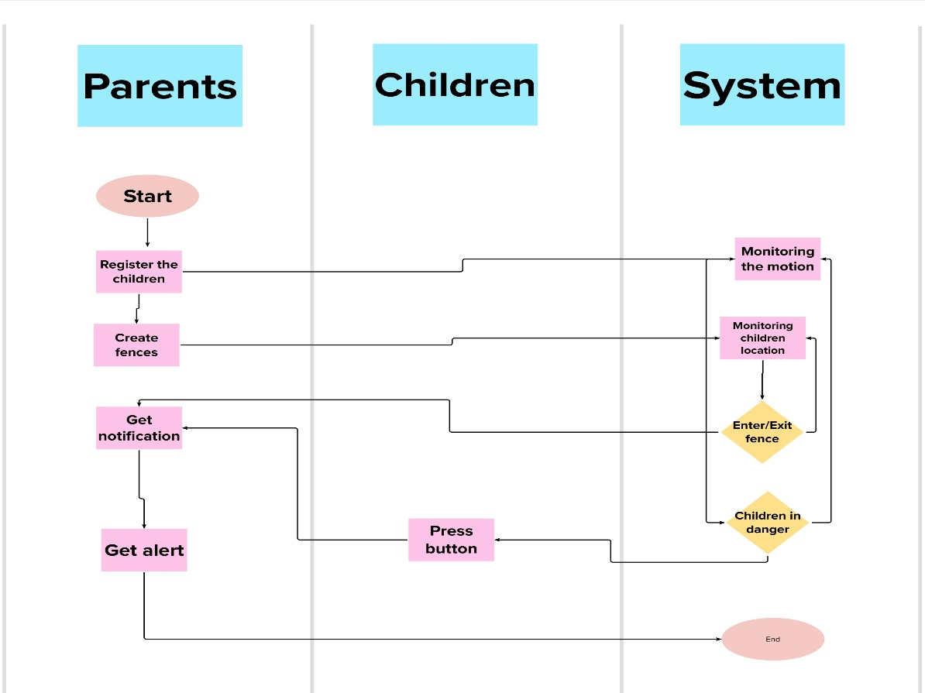**Data Flow Diagrams:**

IOT based safety gadget for child safety monitoring and notification

**User Stories**

Use the below template to list all the user stories for the product.

|  |  |  |  |  |  |  |
| --- | --- | --- | --- | --- | --- | --- |
| **User Type** | **Functional**  **Requirement (Epic)** | **User Story**  **Number** | **User Story / Task** | **Acceptance criteria** | **Priority** | **Release** |
| Customer  (Parents Mobile  user) | Registration | USN-1  (Father) | I can access the location of my children using the credentials provided as a Father. | I can access my account / dashboard and receive confirmation email & click confirm | High | Sprint-1 |
|  |  | USN-2 (Mother) | I can access the location of my children using the credentials provided as a Mother. | I can access my account / dashboard and receive confirmation email & click confirm | High | Sprint-1 |
|  |  | USN-3  (Guardian) | I too can monitor the children’s activities using safety gadget monitoring system. | I can access my account / dashboard and receive confirmation email & click confirm | Medium | Sprint-2 |
|  | Login | USN-4  (if required) | Same function to be performed as in previous cases. | Same function to be performed as in previous cases. | Not Yet  Determined | --------- |
|  | Dashboard | USN-5  (if required) | Same function to be performed as in previous cases. | Same function to be performed as in previous cases. | Not Yet  Determined | ----------- |